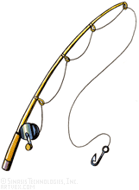  Five Effective Hooks | Personal Narrative  Examples to Hook Readers
In my younger and more vulnerable years my father gave me some advice that I’ve been turning over in my mind ever since: “Whenever you feel like criticizing anyone,” he told me,” just remember that all the people in this world haven’t had the advantages that you’ve had”
(The Great Gatsby)

The two men appeared out of nowhere, a few yards apart in the narrow, moonlit lane. For a second they stood quite still, wands directed at each other’s chests; then, recognizing each other, they stowed their wands beneath their cloaks and started walking briskly in the same direction.
(Harry Potter and the Deathly Hallows)
“Where is Papa going with the ax?” said fern to her mother as they were setting the table for breakfast.
(Charlotte’s Web)
Ba-room, ba-room, baripity, baripity, baripity, baripity – Good. His dad had the pick up going. He could get up now.
(Bridge to Terabithia)

When I wake up, the other side of the bed is cold. My fingers stretch out, seeking Prim’s warmth but finding only the rough canvas cover of the mattress.
(The Hunger Games)

